**! The Unofficial Wasatch Hike & Fly Guide**

**By Gary Begley**

**\*\*Each of the free flight adventures need to be taken seriously because of the risks involved. Many of these lines may not be allowed due to wilderness areas. Fly at your own risk, understanding the potential consequences. These are merely suggestions and I am not liable for your choices\*\***

There is nothing more powerful than taking your free flying to the next level through para-mountaineering. Hike and fly adventures provide pilots with the magic of embracing body, mind and spirit with the rewards being limitless. The richness in adventure flying, not only comes from time in the air, but most importantly the holistic nature in which the experience unravels. The hope in sharing these hike and fly opportunities is to show how hiking up a majestic peak with a wing in tote can inspire pilots to go off the beaten path and challenge themselves and their flying.

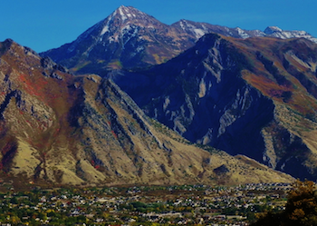

**Wasatch Range, Utah**

The Wasatch Range towers to elevations above 11,800 feet with a vertical gain up to 7,000 feet above the valley floor and stretches over 200 miles. This type of elevation gain is unprecedented and hard to come by in the United States. The Utah mountain playground is an ideal place for all types of adventure sports, especially hike and fly opportunities. It provides endless potential for varying skill levels and for anyone willing to put in the effort. Additional unique features of the Wasatch Range include year round possibilities with superb accessibility.

**Ratings Explained**

Ratings should be taken with a grain of salt; they serve a purpose but are highly subjective. Their intention is to provide you with an idea of what to expect. The ratings listed are based on summer conditions with ideal weather and a solid base fitness level. Winter conditions can change the ratings dramatically, making some of the conditions either easier or more challenging. Naturally, this is also making the assumption that you are avalanche trained, bringing proper backcountry equipment and know how to use it. Additionally, the ratings are assuming that you are able to fly off and not have to walk down…which obviously adds a significant amount of time and physical exertion.

Each hike and fly adventure will have the following ratings attached, in this order.

**Approach Grade** – The approach grade will attempt to shed light on the amount of effort needed to ascend the peak and get to the launch site. This rating boils down to pure physical fitness and ability and has nothing to do with pilot skill. The approach grade will have a number associated with it, rated from I – IV.

1. Short hike, with under a 2,000 feet elevation gain or access by a vehicle with a mild walk to launch. Easy.
2. Approaches realistically done in a few hours, with less than 3,000 feet of elevation gain. Not terribly strenuous and non-technical.
3. Longer approaches (half day) with more vertical elevation gain, over 3,000 feet with the potential of some technicalities and possible exposure. Strenuous.
4. Considerably longer approaches (full day), over 4,000 feet of elevation gain. High likelihood of exposure and technical terrain that may require mountaineering skills. Very strenuous.

**Pilot Skill** – The Pilot Skill Rating is based on the appropriate certifications, when applicable, to fly in the terrain being considered. The route chosen will be based on individual pilot ability. *The pilot ability rating applies to all wings, but is targeted more towards speed/hybrid pilots.*

**Moderate** – Large launch and landing area with little or no obstructions. Landing areas are often visible from launch. Ideal for novice mountain pilots.

**Difficult** – Same as above, but launches may not be as clean with some obstructions that may require maneuvering around, greater attention to wing layout required. Landings are not always visible.

**Very Difficult** – Smaller launches and landing areas that demand a high level of concentration, critical thinking and line choice. Spot landing skills are a must! High level of exposure.

**Severe** – This is game on terrain, pilot must be precise and confident. Can include cliff launching or scree slopes with small technical take offs and landings often with many obstructions. Extreme level of exposure.

**Wing Choices** – Following the ratings on each hike and fly there will be a listing as to which wings are appropriate for the adventure.

**S**= Speed wing, which will be followed by a number that represents the smallest metered speed wing that may be used for that flight. For example, S-12 would be a 12-meter speed wing…meaning any speed wing 12 meters or above is appropriate.

**H**= Hybrid wings

**P**= Paraglider

**T**= Tandem

The Adventure Begins…

**Mt. Olympus**

Mount Olympus is the most recognizable, dominant mountain in the Salt Lake Valley. It can be seen from almost any position in the area, rising 4,800 feet above the valley floor. The steep hike alone is rewarding and aesthetic providing amazing views finishing with a fun rock scramble to reach the summit.

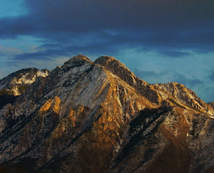

Elevation: 9,026 feet

Descent: (a) North Face 4,700, (b) South Face 4,500

Approach: III

Pilot Skill: (a) Severe, (b) Very Difficult

Wing Choice: S-16, H, P

Seasons: All

**Lower launch possibilities rated as difficult

**Broads Fork Twin Peaks**

Broads Fork Twin Peaks is the highest and most prominent mountain on the eastern Wasatch skyline. It towers 7,000 feet above the valley floor. This hike has some of the most rugged terrain found in the Wasatch. With a high level of effort to reach the summit, the beauty and views make it worth the effort and are second to none.

Elevation: 11,330

Descent: 6,000+

Approach: IV

Pilot Skill: Difficult – Severe

Wing Choice: H, P

Seasons: All

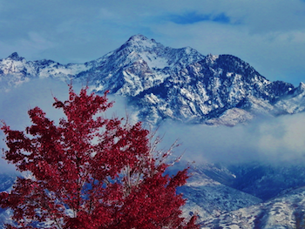

**Mahogany**

One of the classic, best introductory hike and fly experiences. The adventure starts with a beautiful drive through American Fork Canyon. With a short approach, there is easy access to a 3,000 foot flight at the foothills of Mt. Timpanogas.

Elevation: 8,800 feet

Descent: 3,000 feet

Approach: I

Pilot Skill: Moderate

Wing Choice: S-12, H, P, T

Seasons: All

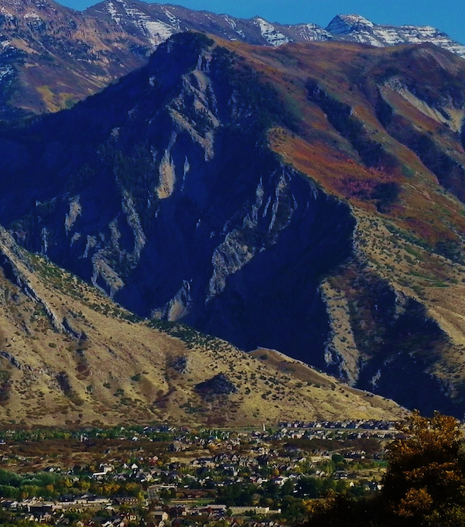

**Box Elder**

This is an often overlooked peak because it stands between the two giants, Mt. Timpanogas and Lone Peak. It offers a fantastic experience for newer para-mountaineers. The sub-peak shown in photo below has numerous launching possibilities from 4,000 feet and below.

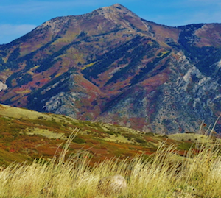

Elevation: 11,100 feet

Descent: 5,000 feet

Approach: III

Pilot Skill: Moderate – Difficult

Wing Choice: H, P, T

Seasons: All

**Lone Peak**

This centerpiece of the Wasatch is easily seen from the north side of the Point of the Mountain while ridge soaring. It is one of the taller peaks, rising 6,000 feet above the valley floor. A huge massif with many rugged, narrow canyons offering endless potential for para-mountaineering.

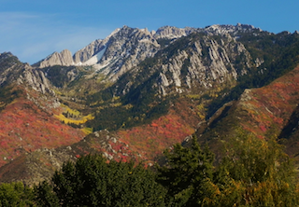

Elevation: 11,253 feet

Descent: Summit 6,000; mid 4,000; lower 2,500

Approach: II – IV

Pilot Skill: Moderate – Severe

Wing Choice: S-16 H, P, T

*smaller speed wings appropriate for lower launches

Seasons: All

**North Timpanogas**

Mt. Timpanogas is the second highest mountain in Utah. It rises 7,000 feet above the valley floor and runs 7 miles in length from north to south. It is one of the most photographed mountains in Utah because of its stunning striations and features.

Elevation: 11,300 feet

Descent: (a) North Face 3,000 feet, (b) West Face 3,000 feet

Approach: III, Winter IV

Pilot Skill: (a) Very Difficult/Severe (b) Difficult

Wing Choice: S-12, H, P, T (West Face)

Seasons: All

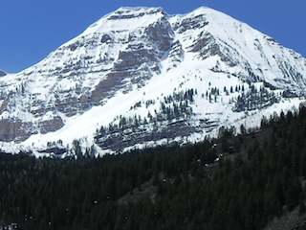

**Mt. Superior**

Need I say more, this is the most popular hike and fly and y’all have done it more than once…

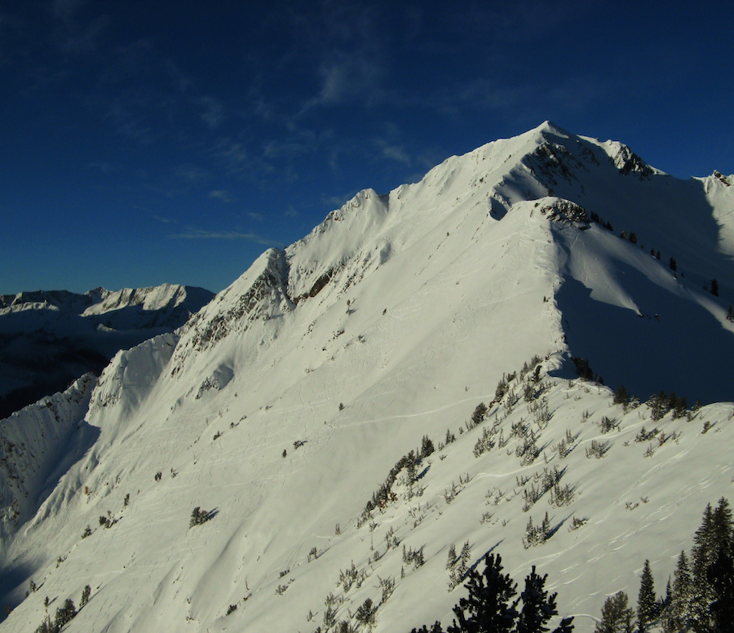

Elevation: 11,231 feet

Descent: South summit 3,000

Approach: II

Pilot Skill: Severe

Wing Choice: S16, H, P

*This peak’s rating in the wintertime is *difficult* and can be flown with a smaller speed wing (S10) due to ease of launching.

Seasons: All

**Monte Cristo**

This Wasatch jewel is visible from the summit of Mt. Superior looking west.

Elevation: 11,100 feet

Descent: 3,000 feet

Approach: II

Pilot Skill: Difficult

Wing Choice: S14, H, P

*Smaller speed wings can be used in winter season

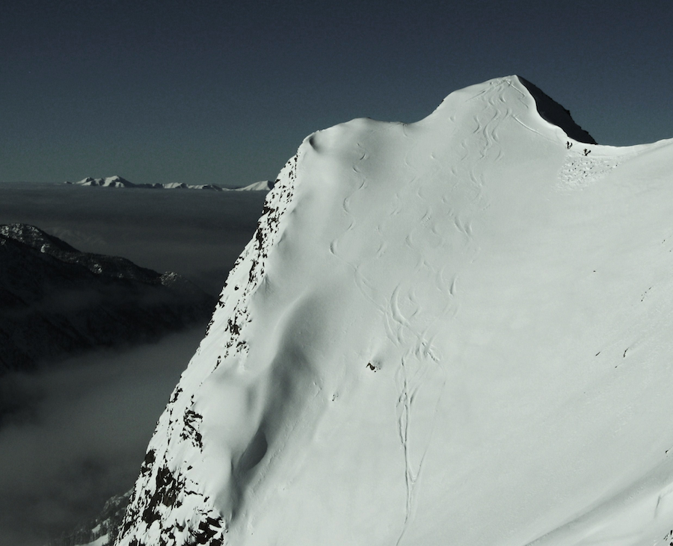

**Little Superior & Cardiff Peak**

These smaller, classic excursions are placed in a beautiful setting, offering great views with easier access. Perfect for newer hike and fly pilots or those just wanting a quickie.

Descents range from 2,000 feet and below. Summer conditions are more challenging where larger speed wings are recommended. In winter, smaller speed wings are acceptable, proving this area to be a very popular training ground.

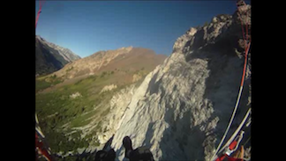

Elevation: (A) Little Superior 10, 400 feet

(B) Cardiff Peak 10,200 feet (aka Hell Gate)

Descent: (A) 2,000 feet

(B) 1,500 feet

Approach: I

Pilot Skill: Moderate/Difficult

Wing Choice: S14, H, P

Seasons: All

**Maybird & Tanners**

Two aesthetic lines approached from Big Cottonwood Canyon with the landing in Little Cottonwood Canyon.

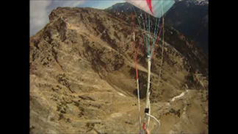

Elevation: 10,800 feet

Descent: 3,500 – 4,000 feet

Approach: III

Pilot Skill: Difficult/Severe

Wing Choice: S16, H, P

Seasons: All

**Mt. Nebo**

Mt. Nebo is the highest peak in the Wasatch. Three major peaks comprise the summit; with the north peak being the highest point. From the peaks flown in the Wasatch, this by far provides the least complicated launches and landings for the bigger lines, endless potential, absolute beauty and aesthetics. This mountain provides a great opportunity for one’s first major hike and fly as well as challenges for even the most experienced.

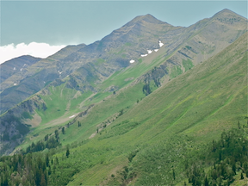

Elevation: North Summit 11,928 feet

South Summit 11,877 feet

South Plateau 11,500 feet

Descent: 6,000 +

Approach: III

Pilot Skill: Moderate/Difficult

Wing Choice: S12, H, P, T

Seasons: All (with a lot more work in winter)

**This guide is a work in progress and will continue to expand as new sites are flown and information is gathered. Don’t hesitate to contact me to share photos, adventures and details.**

**gbegley25@hotmail.com**